Courtesy Meeting with United Nations Rep Ms. Karima El Korri and Senior Economist Dr. Richard Marshall, 17 March 2022
With effect from 20 August 2021, Ms. Karima El Korri has been appointed as the United Nations Resident Coordinator and Representative of the UN Secretary-General in Malaysia, Singapore, and Brunei Darussalem by United Nations Secretary General Antonio Gutterres. The United Nations Association of Singapore (UNAS) accepted a request for a courtesy call by Ms. Karima during her first official visit to Singapore, accompanied by Senior Economist, Dr. Richard Marshall, with the following agenda:
- To learn of the work of UNAS
- Hear UNAS’s views on key economic, social and environmental priorities
- The trajectory towards the Sustainable Development Goals (SDGs) in the context of Singapore
On the evening of 17 March 2022, the UNAS team welcomed Ms. Karima and Dr. Richard at Singapore Recreational Club. UNAS President, Alexander Charles Louis, kicked off the dinner meeting with an introduction of the board members, as well as the student members who were present. He then shared about the history of UNAS and UNAS’s aims and objects.
UNAS has a strong working relationship with past UNDP Resident Coordinators, Ms. Michelle Gyles-Mcdonnough & Dr. Kamal Malhotra. The UNAS president further emphasized that he would like to continue this tradition of a maintaining strong relationship with the UN Resident Coordinators.
UNAS President also shared about past key UNAS activities which are in line with the SDGs. UNAS key activities revolve around 3 main focuses: Education Support, Humanitarian Affairs and Disaster Relief, and Networking and Community Relations.
The UNAS President then invited Ms. Karima to share a few words, before ending the night with a presentation by student members Nguyen Duc Minh Anh and Nguyen Thien Minh Tuan, who introduced their microclimate gadget invention, together with the effects of microclimate on emotion and health.
UNAS is honoured to be able to host this dinner meeting with Ms. Karima and Dr. Richard, and looks forward to continue building a strong rapport with them.

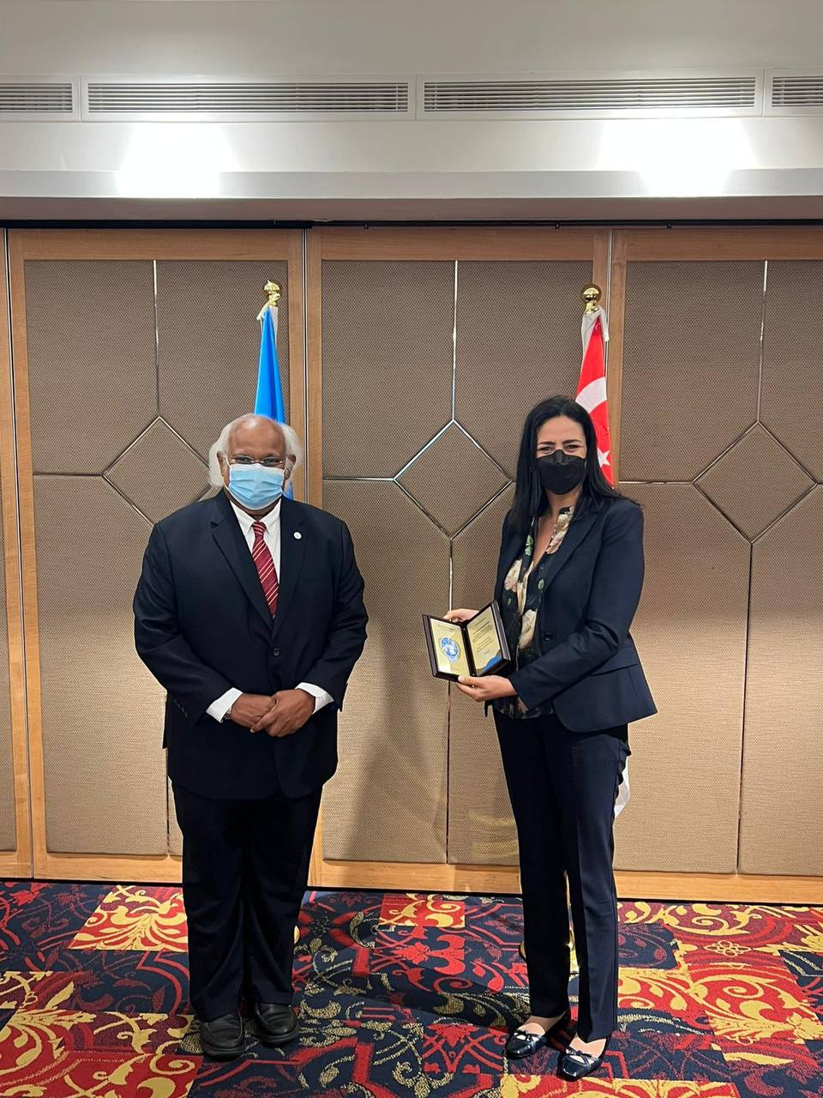
UNAS President Alexander Charles Louis (Left) presenting UN Rep Ms. Karime El Korri (Right) a token of appreciation
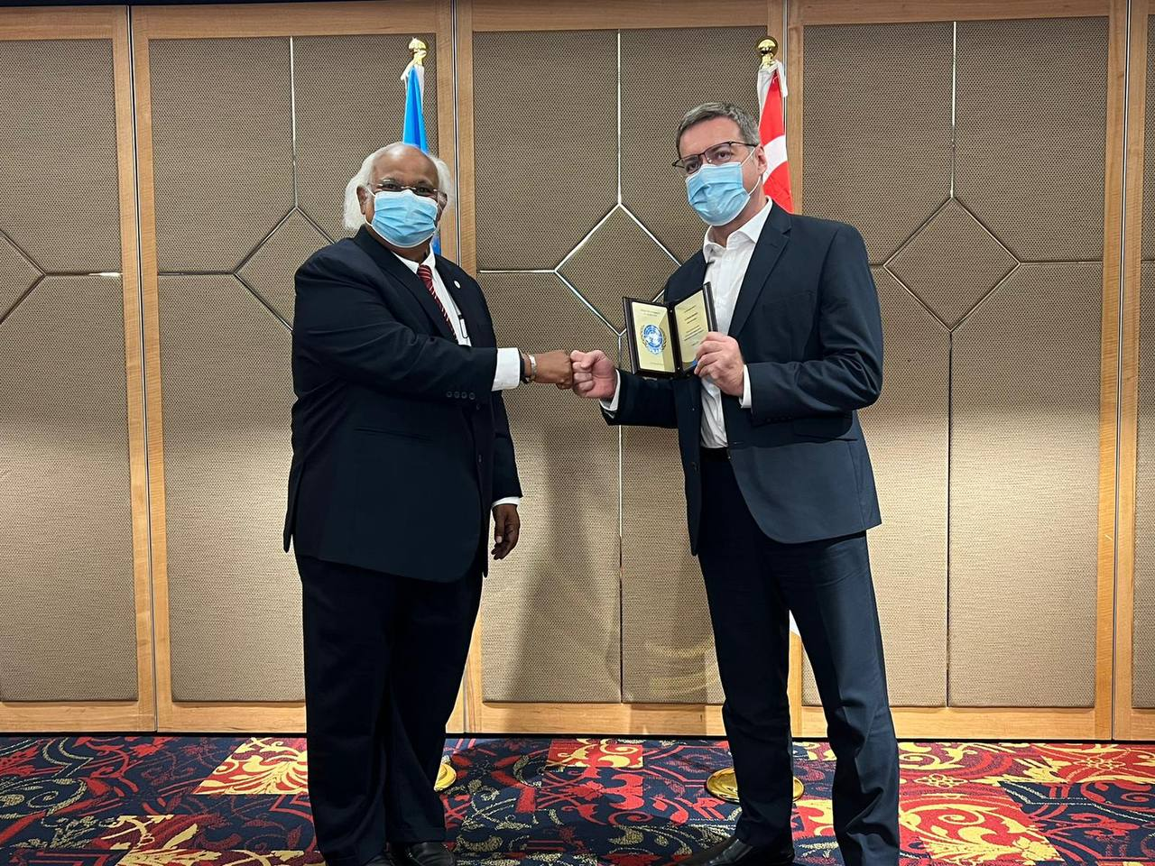
UNAS President Alexander Charles Louis (Left) presenting Senior Economist Dr. Richard Marshall (Right) a token of appreciation
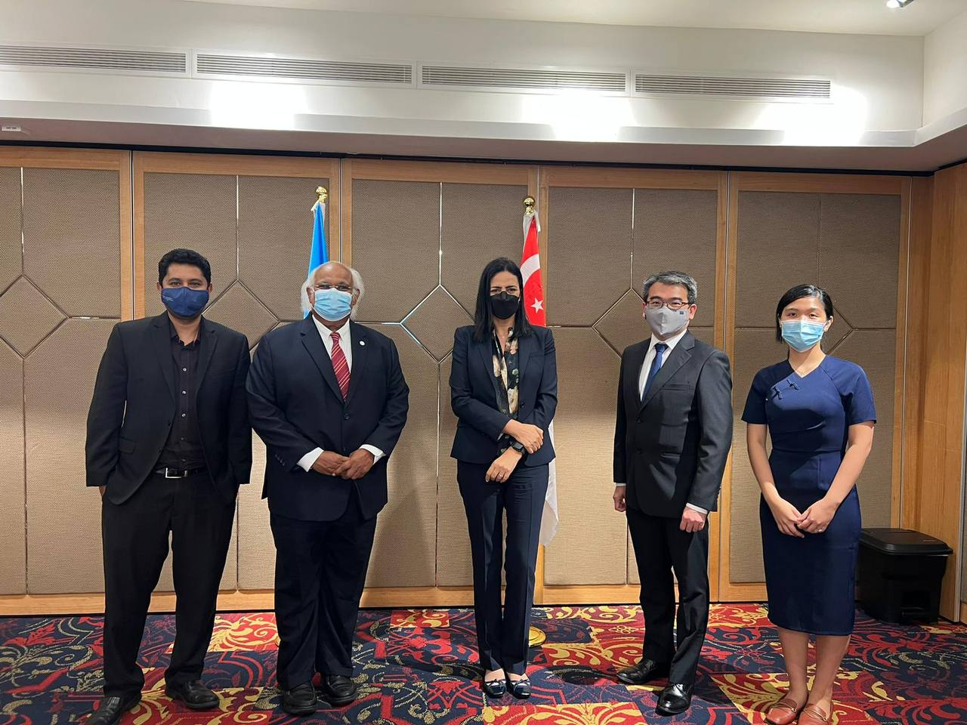
Left to Right: UNAS Director Professor Kamaludeen Mohd Masir, UNAS President Alexander Charles Louis, UN Rep Ms. Karima El Korri, UNAS Honorary Treasurer Mr. Teo Wee Leong, UNAS Secretary-General Ms. Irene Arieputri
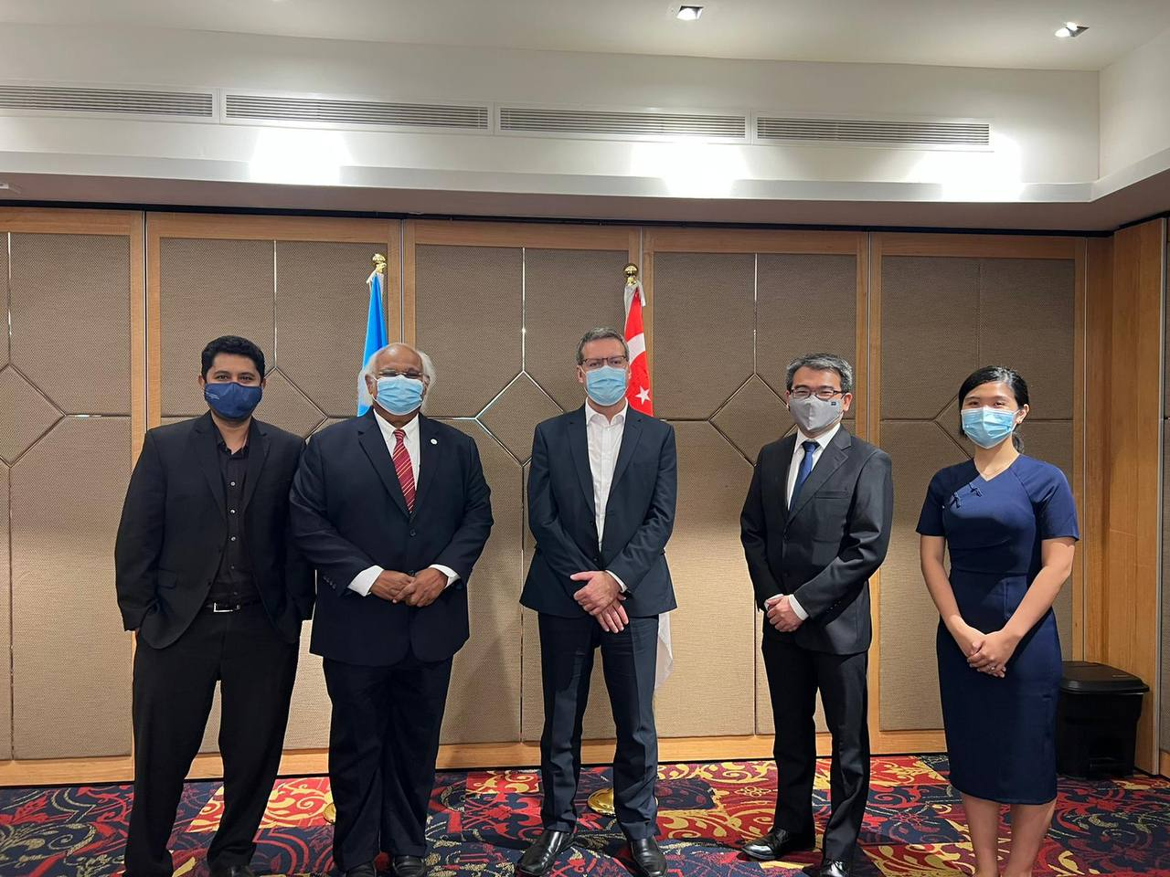
Left to Right: UNAS Director Professor Kamaludeen Mohd Masir, UNAS President Alexander Charles Louis, Senior Economist Dr. Richard Marshall, UNAS Honorary Treasurer Mr. Teo Wee Leong, UNAS Secretary-General Ms. Irene Arieputri
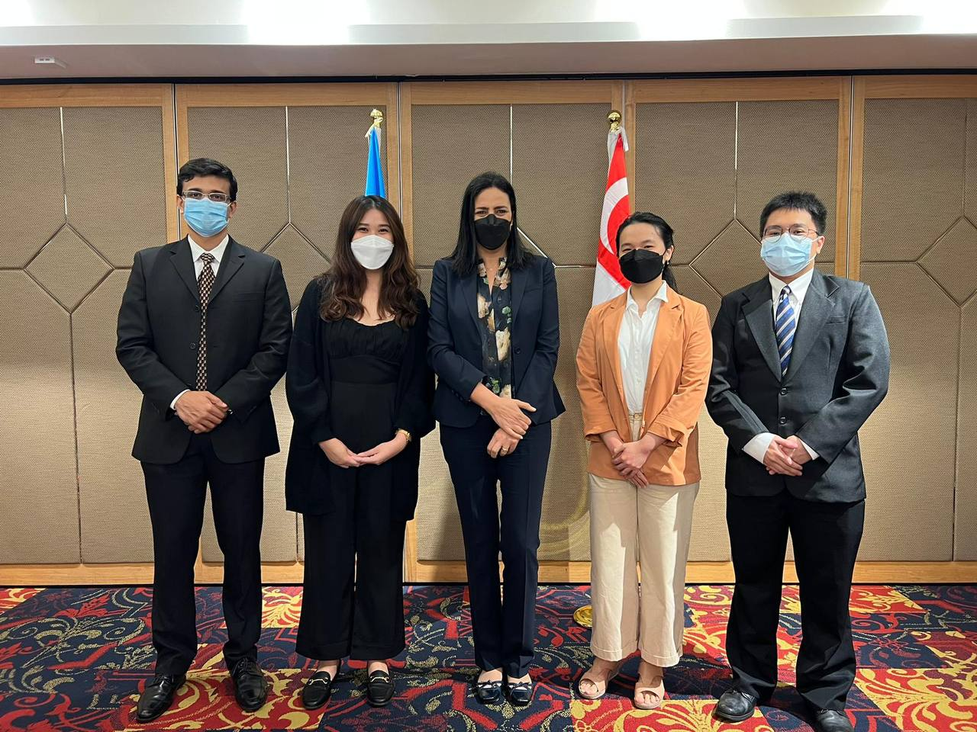
Left to Right: UNAS Director Mr. Ajit Denis Menezes, UNAS Director Ms. Valencia Yeo Hui Ying, UN Rep Ms. Karima El Korri, UNAS Intern Ms. Michelle Bianca Ghozali, UNAS Director Mr. Chevalie Brawijava Rachmat
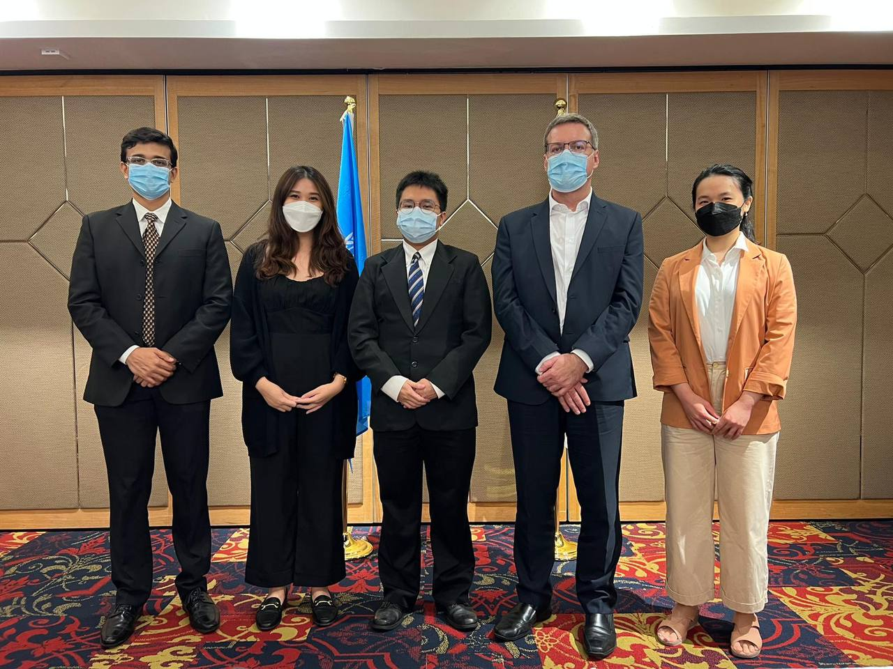
Left to Right: UNAS Director Mr. Ajit Denis Menezes, UNAS Director Ms. Valencia Yeo Hui Ying, UNAS Director Mr. Chevalie Brawijava Rachmat, Senior Economist Dr. Richard Marshall, UNAS Intern Ms. Michelle Bianca Ghozali
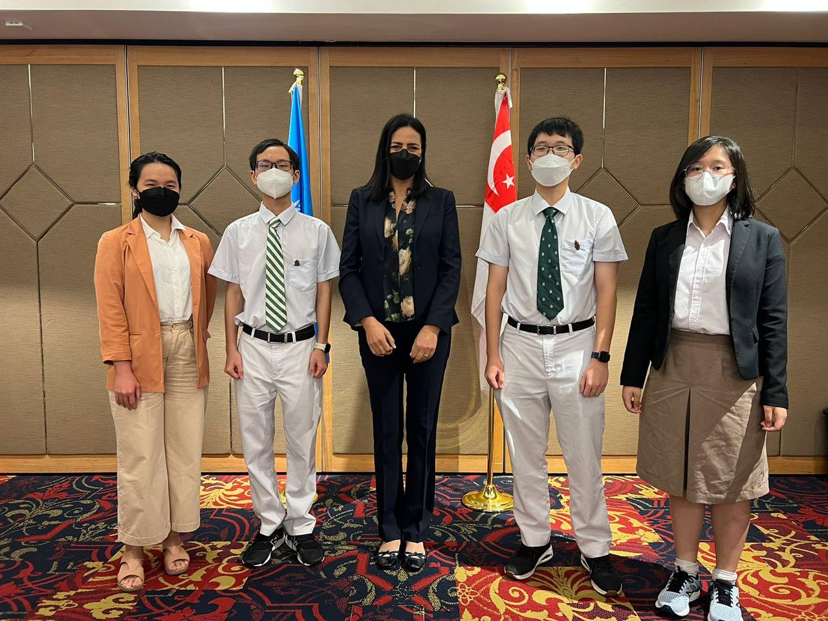
Left to Right: UNAS Intern Ms. Michelle Bianca Ghozali, UNAS Student Member Mr. Nguyen Duc Minh Anh, UN Rep Ms. Karima El Korri, UNAS Student Member Mr. Nguyen Thien Minh Tuan, UNAS Student Member Ms. Laurencia Angel
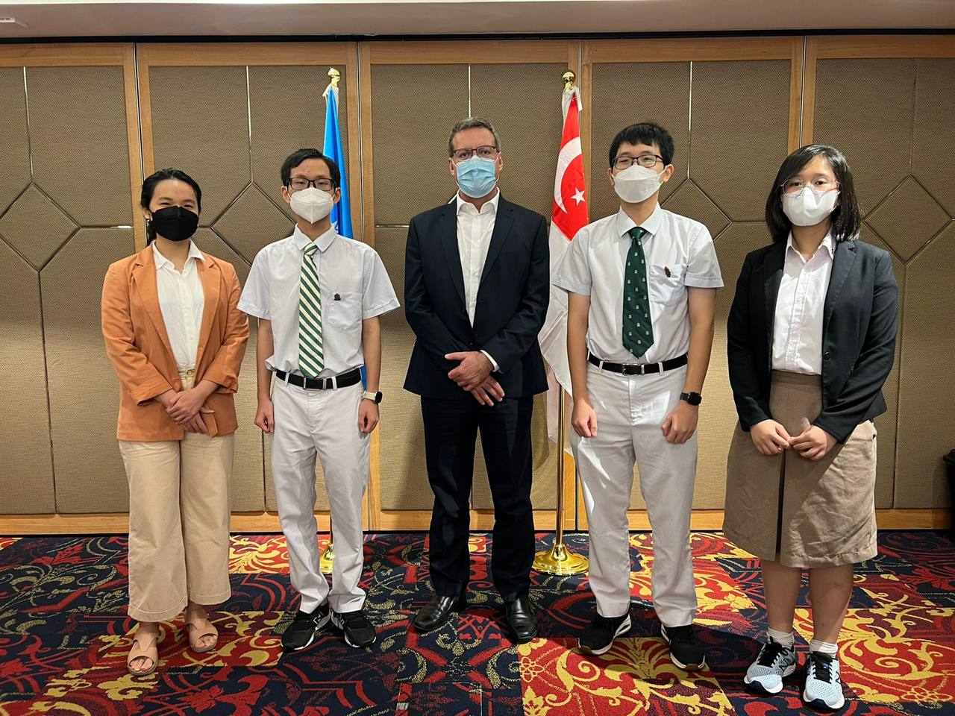
Left to Right: UNAS Intern Ms. Michelle Bianca Ghozali, UNAS Student Member Mr. Nguyen Duc Minh Anh, Senior Economist Dr. Richard Marshall, UNAS Student Member Mr. Nguyen Thien Minh Tuan, UNAS Student Member Ms. Laurencia Angel

